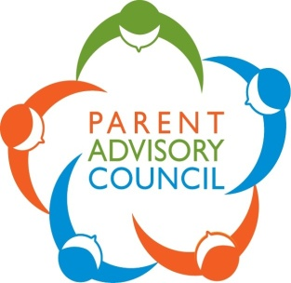

**Brooke Elementary Community**

**Stay connected to school events and news** [**https://www.facebook.com/pg/brookepac/posts/**](https://www.facebook.com/pg/brookepac/posts/)

**All at a Glance....... Reminders of Upcoming Events and Fundraisers**

**Raffle**

**Early bird special – sell your booklet by November 23, return to the office and get a free entry into the draw for every booklet sold.**

**Tickets, sold and unsold returned to the school by November 27 to be entered into both the vendor and basket raffle draws.**

**Tickets not received by at the end of the school day on Friday, December 4, will not be entered into the basket draws.**

**Vendor prize draws everyday of the Market from November 29 to December 5.**

**Basket draws live on the final day of the market, December 6.**

**Online Winter Market**

**Support local business, supporting Brooke. November 29 to December 6.**

**For details go online to our facebook page at** [**https://www.facebook.com/pg/brookepac**](https://www.facebook.com/pg/brookepac)

**Live Events during the Market**

**For details and to sign up for events during the week of the market go to:**

**Poinsettia/plants/Christmas Wreaths**

**Order deadline is December 2nd with delivery on December 11th**

**Order at https:** [**https://brookeelementary.growingsmilesfundraising.com**](https://brookeelementary.growingsmilesfundraising.com)

**Purdy’s**

**Order deadline is Wednesday, November 25th with pick up Friday, December 11th**

**Order at** [**https://fundraising.purdys.com/829444-79048**](https://fundraising.purdys.com/829444-79048)

**Gift Cards**

**Order Dates: two opportunities to order gift cards**

* **First order due Wednesday, November 25th, delivered on Friday, December 4th**
* **Second order due Monday, December 7th, delivery on Wednesday, December 16th.**

**Order forms and instructions to order on the school website at:** [**https://br.deltasd.bc.ca/news-events/news/november-16th-20th/**](https://br.deltasd.bc.ca/news-events/news/november-16th-20th/)

**Card Art**

**Order due Monday, November 23.**

**Order at** [**www.artcardsbykids.com**](http://www.artcardsbykids.com)**. Click on PARENT ORDER. Enter the RED CODE on the back of the sample card.**

**Sample of the Christmas decoration, on display in the window at the school’s main entrance.**

**Neufeld**

**Delivery Friday, November 20th at 3pm outside the school**

**Spirit Wear**

**Orders are in. Expect delivery soon.**

**Flipgive**

**Join our team now using our invite code SRRV22 in one of 2 ways:**

1. **Download the FlipGive app at** [**https://www.flipgive.com/app?joincode=SRRV22**](https://www.flipgive.com/app?joincode=SRRV22)
2. **Join online at** [**https://www.flipgive.com/teams/join?fundraiser_name=Crystal1%20Kandler&joincode=SRRV22**](https://www.flipgive.com/teams/join?fundraiser_name=Crystal1%20Kandler&joincode=SRRV22)