BROOKE ELEMENTARY FUNDRAISER
Brooke Elementary PAC is excited to offer the cookie/pie/frozen meat fundraiser through Neufeld Farms once again! This is a great way to stock up your freezer with some yummy meals and treats during these chilly evenings and unsettling times.
There are 3 ways to order:
Online: Through the school Munch-A-Lunch site
Etransfer: Please scan your order and etransfer payment to brooke.council@gmail.com
Cheque/Cash: Please send your order form and payment to school with your student

Order deadline is Tuesday, November 10th.

Pick up will be Friday, November 20th at 3:00 out front of the school. We will have a process in place to ensure distancing and safety for all involved. Please include your email address on your order and we will send out a reminder about pick up a few days prior.

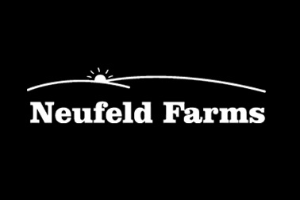
Thanks for supporting Brooke Elementary!

